1. **INTRODUCTION**
   1. *overview*
      * *Description of the project*

Project Description:

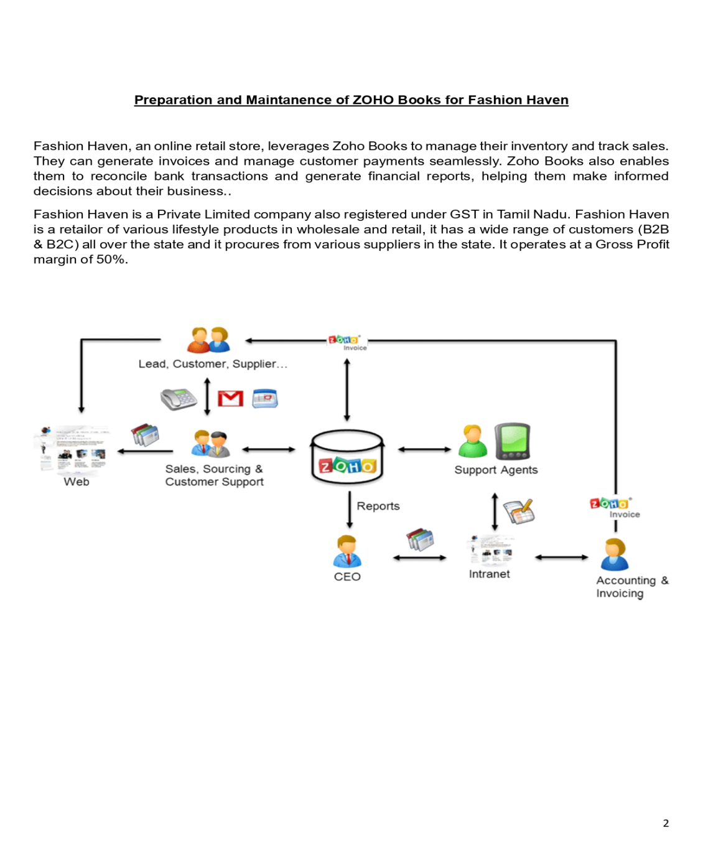

1. **Problem definition & design Thinking**
   1. *Empathy map*

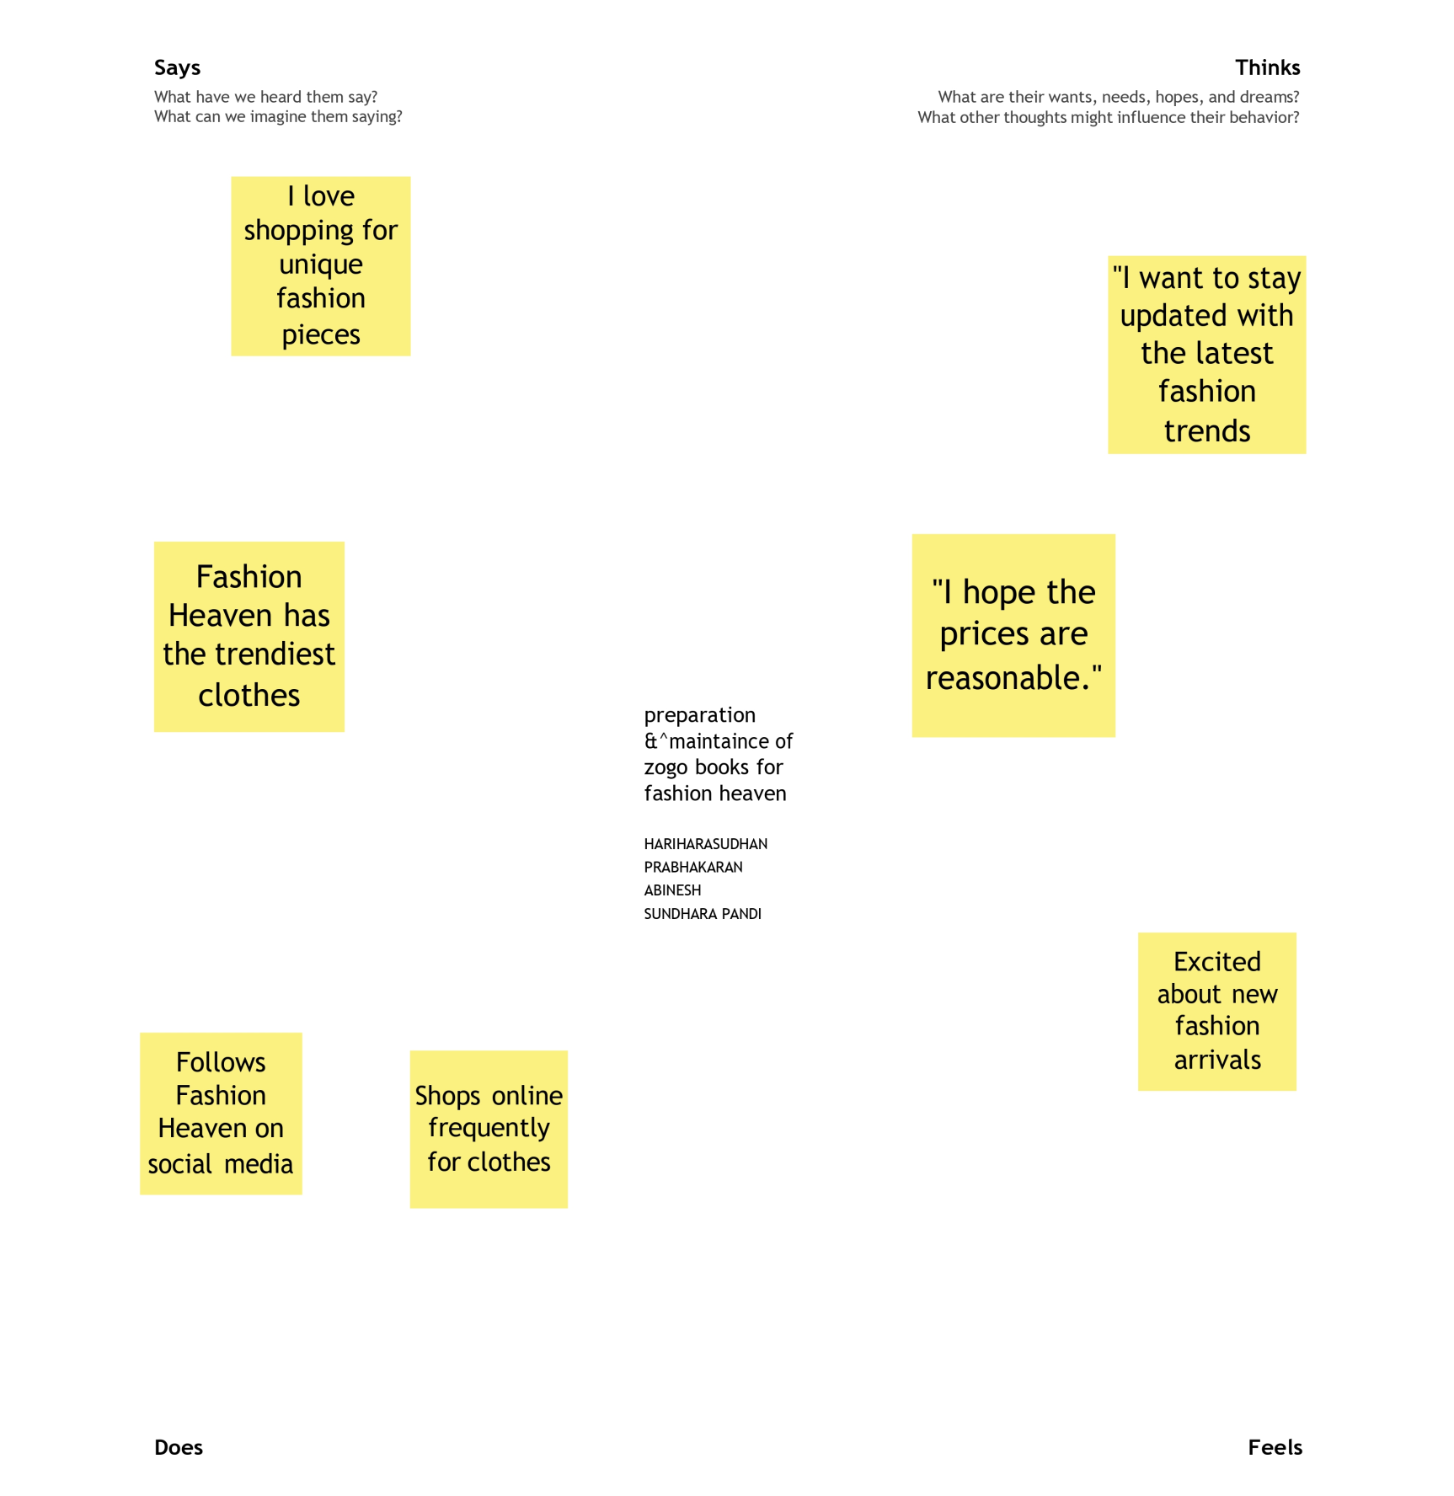

* 1. *Ideation & Brainstorming map*

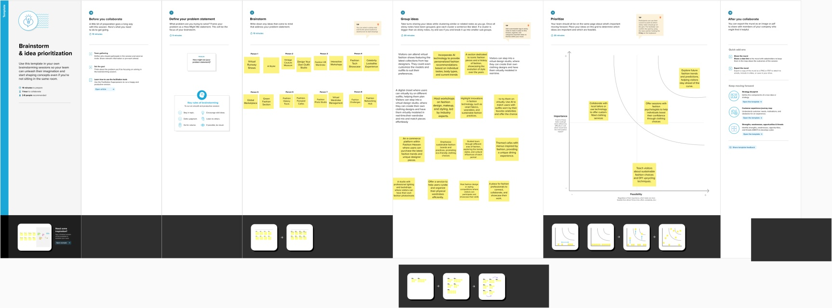

1. **Result Profit&loss**

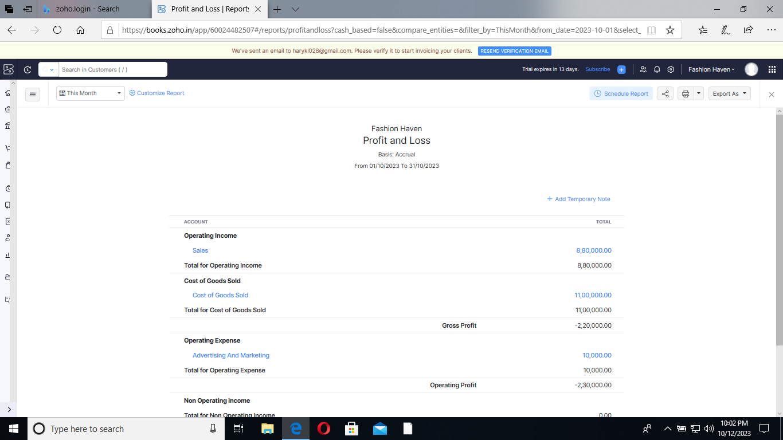

Balance sheet:

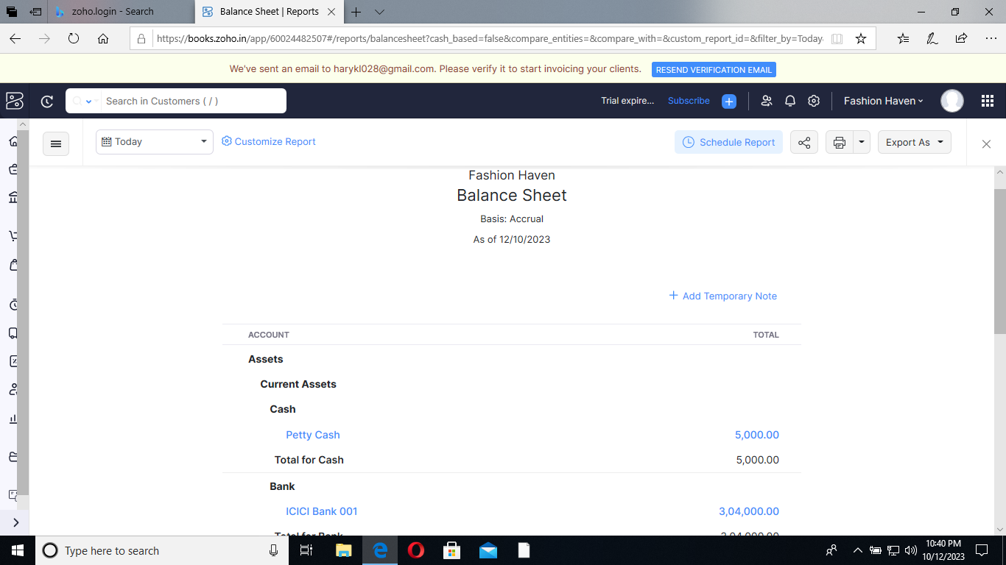

Purchase order:



ADVANTAGES OF FASHION HAVEN :

**t’s a universal language –**understood by millions of fashion and style lovers worldwide. When someone who follows fashion meets someone else who also follows fashion, there’s an immediate bond with a wonderful interest in common.

**Fashion is a means of personal expression.**Fashion gives us an opportunity to make a statement to the world about our sense of aesthetics and beauty.

**Fashion is an art form.** Putting together an outfit in the morning and accessorizing it creates a human work of art.

**Fashion is fun.**Shopping for new clothes can be a thrilling experience for a fashion lover — looking at latest garments on display is like discovering new treasures.

**Fashion can build self-confidence.**Ask anyone who gets one compliment after the next when they’re out in public spaces. Fashion inspires those who see us.

**Fashion makes you more attractive to others.**Even though it is widely said not to judge a book by its cover, human nature makes this a common practice so why not enjoy it? Before I discovered fashion I felt completely invisible in public. Now hundreds of people know me and are eager to see what I’m wearing. That’s been a very positive lifestyle change for me.

DISADVANTAGES OF FASHION HAVEN :

**It costs money to be fashionable.** Spending $70 for a nice T-shirt can put a dent in your wallet, as can buying a pair of designer jeans for $225 USD.

**You will be judged more by others.** This is especially true if you are shooting for a certain style and you miss the mark.

**Some people will envy you and be critical.**If you walk around town with your $6,400 USD Chanel handbag, some folks might think you’re showing off.

**Fashion advertising can overwhelm people.**The garment industry bombards both men and women with endless marketing messages.

1. *APPLICATIONS:*

FASHION HAVEN

1. **Conclusion:**
2. The global vision that has brought improved travel and trade and increased interdependency among countries also calls for a common vision of health around the world. All countries are vulnerable to the ever-present threats of infectious disease, outbreaks, and epidemics. At the same time, there are opportunities for shared innovation and universal purpose as many countries that suffer from similar disease burdens strive to develop best practices and strong health systems for their citizens.
3. Throughout this consensus study, the committee emphasized the need for a more holistic examination of problems and challenges in global health. Such an approach applies not only to issues of global health security but also to the external factors that influence health security, such as the building of general capacity in countries and the creation of strong societies that foster stability, healthy lifestyles, and accessible economic opportunities. Unless core capacities and strong health systems are developed around the world, the global risk of infectious disease will continue to threaten the health and security of the United States. Beyond the imperative of addressing infectious disease threats, it is necessary to understand the fundamental connection between health and economic prosperity. In addition to the economic costs of responding to infectious disease outbreaks, the increasing prevalence of chronic or noncommunicable diseases (NCDs) has negatively affected global economies—compromising societal gains in life expectancy, productivity, and overall quality of life ([WEF, 2017](https://www.ncbi.nlm.nih.gov/books/NBK458477/)).
4. **FUTURE SCOPE:**

India has always been known for its rich textile heritage and intricate craftsmanship, and the fashion industry in the country has seen a significant boom in recent years. With the rise of e-commerce and social media, the future of fashion designing in India looks brighter than ever before.

One of the main factors driving the growth of the fashion industry in India is the increasing purchasing power of the middle class. As more and more people enter the middle class, there is a growing demand for affordable yet stylish clothing. This has led to the rise of fast fashion brands and the emergence of new designers who cater to this market.